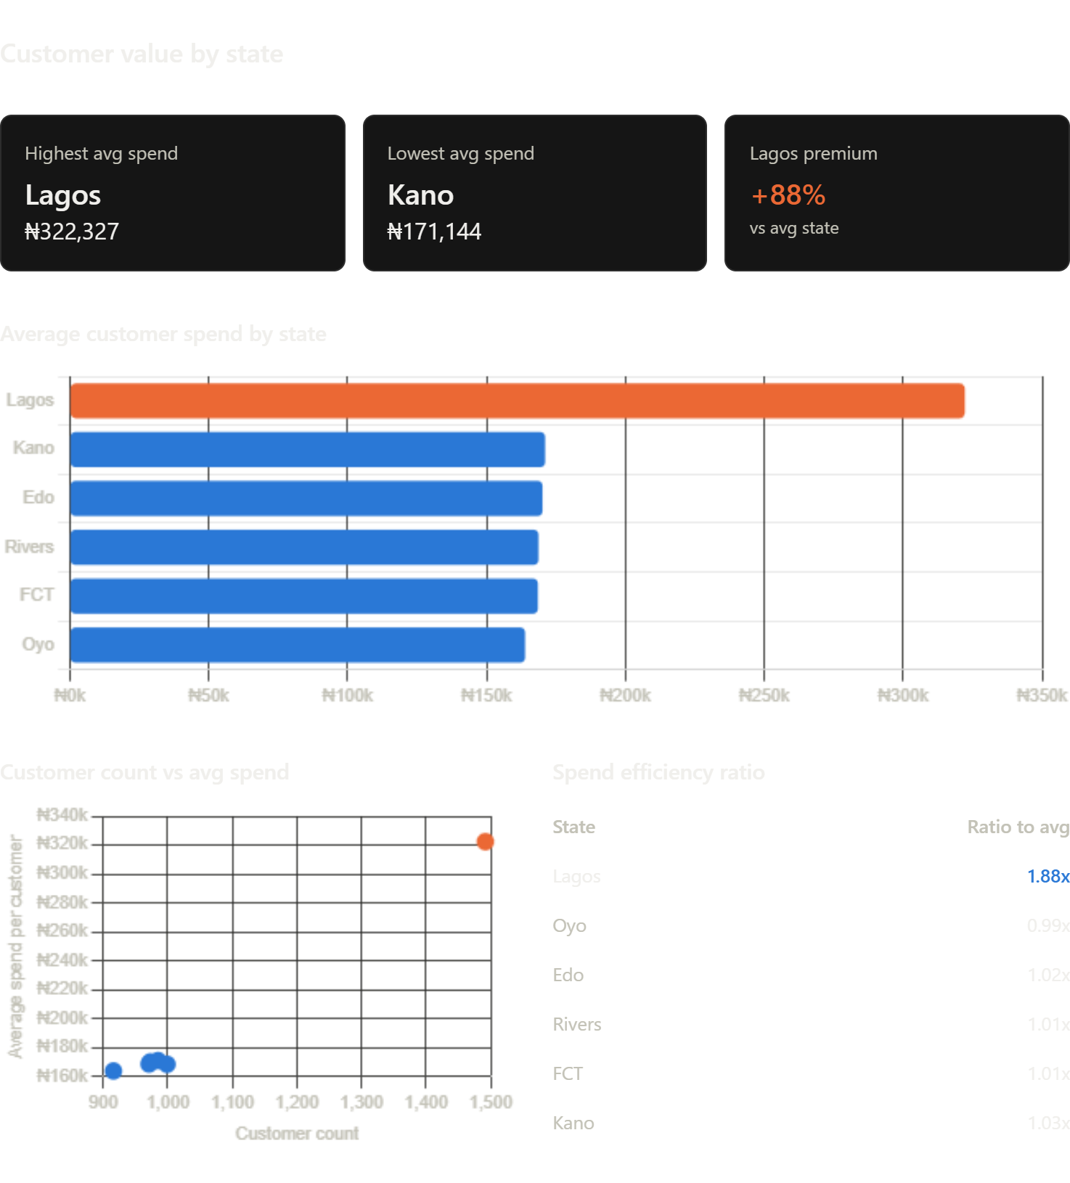

Lagos is a Premium Market

The Three-Part Story
1. Average Customer Value is Nearly 2x Higher in Lagos
- Lagos: ₦322,327 per customer
- Other states: ₦164-171k per customer
- Difference: +88%
This isn't just more customers. Lagos customers are individually worth almost twice as much. This points to:
- Premium customer segment (higher income, purchasing power)
- Better product mix (higher-margin or higher-ticket items selling better in Lagos)
- Higher repeat purchase rate (customers buy more often)
- Better monetization (higher conversion rates, upselling, or average order value)

2. Other States Are Clustered (and Underperforming)
Kano, Edo, Rivers, FCT, and Oyo all have:
- Similar customer counts (916–999)
- Nearly identical average spend (₦164–171k)
- They're performing like a single market, not five separate ones
This suggests:
- Standardized customer acquisition (same messaging, same product mix regardless of state)
- Untapped opportunity: If you could lift Kano customers from ₦171k to ₦220k average (Lagos-like positioning), you'd add ₦48M in revenue with zero new customer acquisition
- Market segmentation gap: You're not tailoring regional differences

3. Lagos Has Both Saturation AND Dominance
Lagos = 93% of customers among your top 6 states, but 65% of revenue among those same states. This paradox means:
- Lagos is past initial growth (saturating, but highly profitable)
- Other states are still in acquisition phase (many customers, not yet monetizing them)
- Different strategies needed:
  - Lagos → retention, upselling, margin optimization
  - Other states → product positioning, pricing strategy, repeat-purchase campaigns

Actionable Recommendations
Issue # | Priority | Finding | Impact | Timeframe
1 | High | Analyze Lagos vs other states product mix. Why does office furniture sell premium in Lagos? | Replicate that positioning in Kano/Edo | 2 weeks
2 | High | Test premium product positioning in Kano/Edo. Current ₦171k avg is 50% of Lagos. Targeted campaigns could bridge gap. | ₦100M+ incremental if successful | 2 weeks
3 | Medium | Investigate repeat purchase rate by state. Lagos's high avg suggests loyalty or bulk orders. Quantify this. | Build retention playbook for high value repeat segment | 2-4 weeks
4 | Medium | Run cohort analysis: customer lifetime value by state. Are Lagos customers staying longer? Worth more over 12 months? | Informs acquisition spend by geography | 2-4 weeks
5 | Low | Test dynamic pricing by state. If Lagos market can bear 2x, explore price elasticity in others | 5-10% margin uplift if ceiling exists | 4 weeks +

